EXPT NO:6 | INTEGRATE DATA FROM VARIOUS SOURCES FOR COMPREHENSIVE ANALYSIS USING TABLEAU AND POWERBI
DATE: 24.07.2026

PRE-LAB QUESTIONS (PROVIDE BRIEF ANSWERS TO THE FOLLOWING QUESTIONS)

- What is data integration in the context of Business Intelligence (BI)?
Data integration is the process of combining data from different sources into a single, unified view for analysis. It helps organizations bring together information from databases, spreadsheets, and other systems. This provides a complete picture of the business. Data integration improves the accuracy and consistency of reports. It also supports better decision-making by providing reliable information.

- Explain the difference between a join and a data blend in Tableau.
A join combines tables from the same data source based on a common field, creating a single dataset. A data blend combines data from different data sources while keeping them separate. Joins are performed before analysis, whereas data blending happens during visualization. Joins are generally faster, while data blending is useful when data comes from multiple sources. Both methods help integrate related data for analysis.

- What are relationships and cardinality (e.g., one-to-many, many-to-many) in Power BI's data model?
Relationships connect different tables using common fields in Power BI. Cardinality defines how records in one table relate to records in another table. Common types include one-to-one, one-to-many, and many-to-many. These relationships help Power BI combine data correctly during analysis. A well-designed data model improves report accuracy and performance.

- Why is data quality (e.g., consistent naming conventions, data types) crucial when integrating data from different sources?
Good data quality ensures that information from different sources can be combined correctly. Consistent naming conventions and correct data types help avoid errors during data integration. Poor-quality data may lead to incorrect reports and inaccurate analysis. Clean and consistent data improves the reliability of dashboards. It also supports better business decisions.

- Name two common challenges encountered during data integration.
Two common challenges are missing or inconsistent data and different data formats. Missing values can reduce the accuracy of analysis, while inconsistent formats make it difficult to combine datasets. Other challenges include duplicate records and mismatched data types. Proper data cleaning and transformation help overcome these issues. This ensures successful data integration and reliable reporting.

IN-LAB EXERCISE:
OBJECTIVE:
To connect to, combine, and model data from multiple disparate sources in Tableau and Power BI to create a unified, comprehensive dashboard for holistic analysis. PROCEDURE:
- Data Collection:
  - Import data from at least two different sources (e.g., a CSV file and an Excel file).
  - Dataset 1: Sales Data (CSV file) with fields like Order ID, Order Date, Region, Sales Amount.
  - Dataset 2: Regional Sales Targets (Excel file) with fields like Region, Sales Target, Target Year.
- Data Preparation and Transformation:
  - Clean both datasets: Check for inconsistencies in region names (e.g., "N. America" vs. "North America"). o Ensure data types are correct (e.g., Sales Amount is numeric, Order Date is a date).
  - Handle any missing values as appropriate.
- Data Integration and Modeling:
  - Tableau: Use the Data Source pane to establish a relationship or join between the Sales Data and Regional Targets tables using the common Region field.
  - Power BI: Use the Model view to create a relationship between the two tables, connecting them on the Region column. Define the cardinality (e.g., many-to-one).
- Create Calculated Fields for Comparison:
  - Develop new measures that leverage both datasets.
  - Examples: Target Achievement % = (SUM(Sales) / SUM(Sales Target)) * 100
  - Sales vs. Target Variance = SUM(Sales) - SUM(Sales Target)
- Design a Comprehensive Dashboard:
  - Create visuals that combine data from both sources to provide a single view of performance.
  - Add KPI cards for Total Sales and Overall Target Achievement %. o Use a gauge chart or bullet chart to show sales performance against targets for each region. o Create a combined bar chart showing Actual Sales vs. Target Sales by Region.
  - Use a map to visualize the Sales vs. Target Variance, highlighting underperforming or overperforming regions.
- Validate Data Integrity:
  - Verify that the joined/related data is accurate by cross-checking values. o Ensure filters on the dashboard correctly update visuals that use data from both sources.
- Publishing and Sharing:
  - Tableau: Publish the workbook to Tableau Public or Tableau Server.
  - Power BI: Publish the report to Power BI Service and share the link.
Experiment Datasets:
Dataset 1: Retail Sales Data (CSV) Fields Used:
- Order ID – Unique identifier for each order
- Order Date – Date of the sales transaction
- Region – Sales region
- Sales – Sales revenue from the order
Dataset 2: Regional Sales Targets (Excel) Fields Used:
- Region – Sales region (used as the key for joining/relationship)
- Sales Target – The sales goal for the region
- Target Year – The year for which the target is set

Power BI
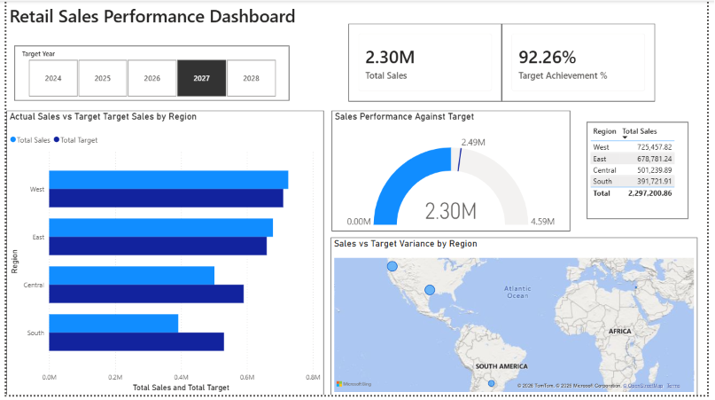

TABLEAU
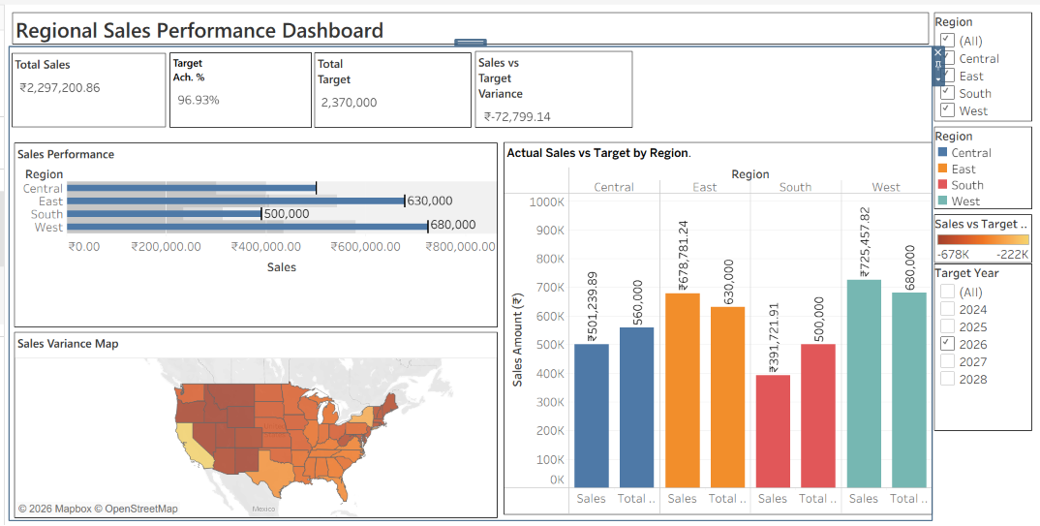

POST-LAB QUESTIONS (PROVIDE BRIEF ANSWERS TO THE FOLLOWING QUESTIONS)
- How did integrating the sales targets data provide a more complete analytical picture than using the sales data alone?

Integrating the sales targets with the sales data helped compare actual performance against planned goals. It showed whether each region met or missed its target instead of displaying only sales values. This made it easier to measure performance accurately. The dashboard also highlighted regions that required improvement. Overall, it provided better insights for decision-making

- Describe the type of join or relationship you used to combine the two datasets and explain why it was the appropriate choice.

A relationship was created between the Sales dataset and the Regional Sales Targets dataset using the Region field. This allowed Tableau and Power BI to combine information from both sources without merging the original data. The relationship ensured that sales and target values could be compared correctly. It also supported interactive filtering across both datasets. This was suitable because Region was the common field in both tables

- What challenges, if any, did you face regarding data granularity or mismatched keys (e.g., different region names) between the two sources?

The main challenge was ensuring that the region names matched correctly in both datasets. Any spelling differences or inconsistencies could have prevented the relationship from working properly. The sales data contained many records for each region, while the targets were organized by region and year. Careful data cleaning and checking were needed before creating the relationship. This helped maintain accurate analysis.

- How can creating variance calculations (e.g., Sales vs. Target) help a business manager make better decisions?
Variance calculations show the difference between actual sales and target sales. This helps managers quickly identify regions that are performing well or falling behind. They can focus on improving underperforming regions and recognize successful ones. It also supports better planning and resource allocation. Overall, it enables more informed business decisions.

- What other data source (e.g., marketing campaign data, customer demographics) could you integrate to further enrich this analysis, and what new insights might it provide?
Customer demographics or marketing campaign data could be added to the dashboard. This would help analyze how different customer groups or marketing efforts affect sales performance. Managers could identify which campaigns generate higher sales in each region. It would also improve customer understanding and business planning. This additional information would provide deeper and more meaningful insights.

RESULT:
The retail sales and regional targets datasets were successfully connected, cleaned, and integrated in both Tableau and Power BI. By creating relationships between the sources, a unified data model was built. The resulting comprehensive dashboard visualized sales performance against set targets, enabling variance analysis and providing deeper, context-rich insights into regional performance that were not possible with a single data source.

ASSESSMENT

Description |  | Max Marks | Marks Awarded
Pre Lab Exercise |  | 5
In Lab Exercise |  | 10
Post Lab Exercise |  | 5
Viva |  | 10
 | Total | 30
 | Faculty Signature

